Re-Assure Claim Creation API Testing  
  
  
  
  
1) User is able to create the claim by leaving the Address field blank which is mandatory as per the shared document. (06378936400069)  
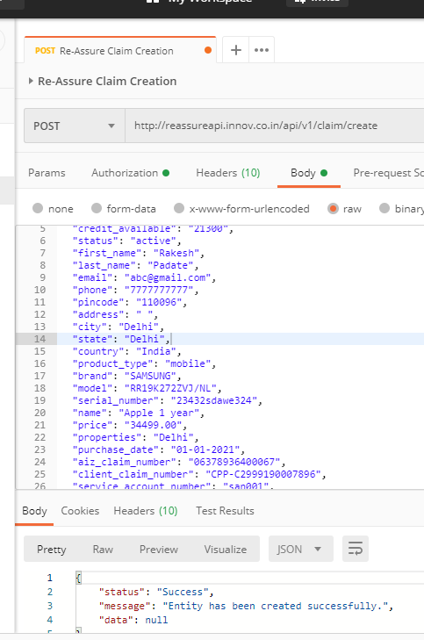

2. User is able to create the claim by leaving the claim_status field blank which is mandatory as per the shared document. (06378936400061)

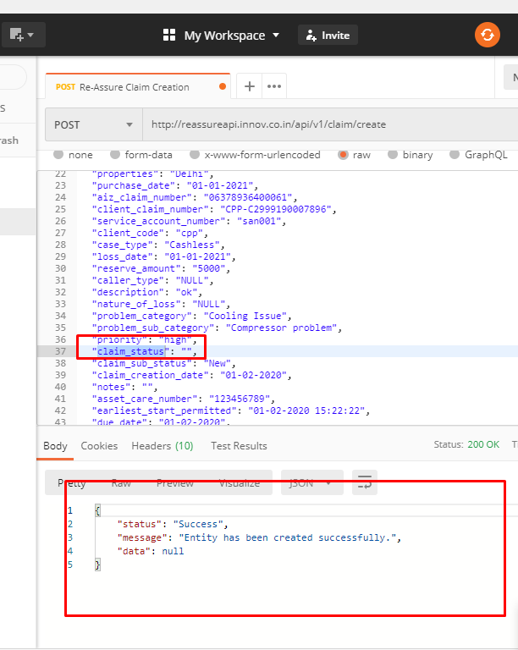

3. 2. User is able to create the claim by leaving the claim_sub_status field blank which is mandatory as per the shared document. (06378936400060)  
  
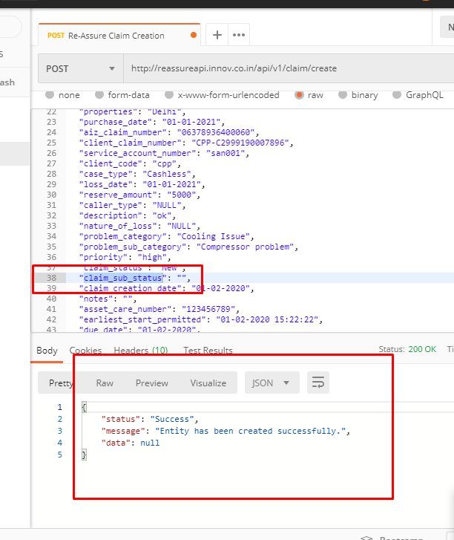

4. No validation message appears for entering invalid data in address,city,state field.

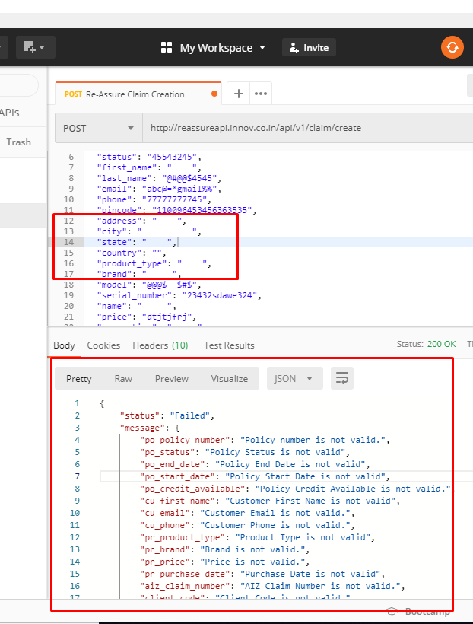

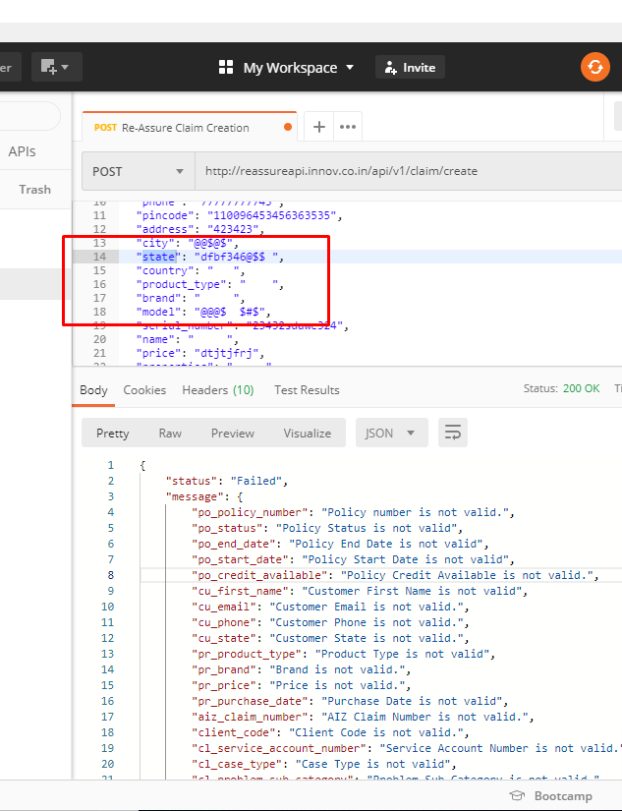

5.No validation message appears for entering invalid data in model field.  
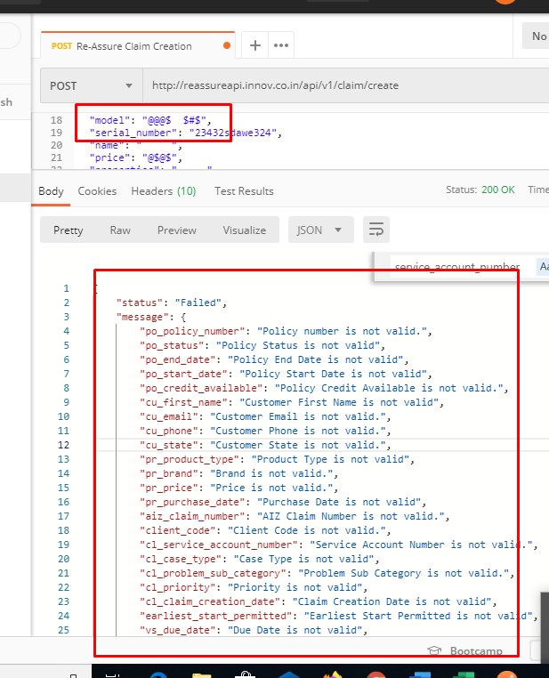

6. No validation message appears for entering invalid data in claim_status and claim_sub_status field

Data sent   
{

"policy_number": " ",

"start_date": "2020-16-01",

"end_date": " ",

"credit_available": "$@FW",

"status": "45543245",

"first_name": " ",

"last_name": "@#@@$4545",

"email": "abc@=*gmail%%",

"phone": "77777777745",

"pincode": "110096453456363535",

"address": "423423",

"city": "@@$@$",

"state": "dfbf346@$$ ",

"country": " @$$$ ",

"product_type": "24323$$",

"brand": "@$@$",

"model": "@@@$ $#$",

"serial_number": "23432sdawe324",

"name": " ",

"price": "@$@$",

"properties": " ",

"purchase_date": "dhdxh",

"aiz_claim_number": "@$@$$##$#$#!",

"client_claim_number": " ",

"service_account_number": "@@$$ 3646",

"client_code": "$@$$#$",

"case_type": " ",

"loss_date": "01-2021-32",

"reserve_amount": " RWR#",

"caller_type": "$$3566",

"description": "4564586",

"nature_of_loss": " ",

"problem_category": " ",

"problem_sub_category": "@$FFFFFFFF2535",

"priority": " ",

"claim_status": "@$@$$",

"claim_sub_status": "@$$",

"claim_creation_date": "36-02-2020",

"notes": "",

"asset_care_number": " ",

"earliest_start_permitted": "01-ytjfti6868@$#$",

"due_date": " ",

"expected_datetime_closure": "020",

"repeat_repair": "@$$$"

}

Output

{

    "status": "Failed",

    "message": {

        "po_policy_number": "Policy number is not valid.",

        "po_status": "Policy Status is not valid",

        "po_end_date": "Policy End Date is not valid",

        "po_start_date": "Policy Start Date is not valid",

        "po_credit_available": "Policy Credit Available is not valid.",

        "cu_first_name": "Customer First Name is not valid",

        "cu_email": "Customer Email is not valid.",

        "cu_phone": "Customer Phone is not valid.",

        "cu_state": "Customer State is not valid.",

        "pr_product_type": "Product Type is not valid",

        "pr_brand": "Brand is not valid.",

        "pr_price": "Price is not valid.",

        "pr_purchase_date": "Purchase Date is not valid",

        "aiz_claim_number": "AIZ Claim Number is not valid.",

        "client_code": "Client Code is not valid.",

        "cl_service_account_number": "Service Account Number is not valid.",

        "cl_case_type": "Case Type is not valid",

        "cl_problem_sub_category": "Problem Sub Category is not valid.",

        "cl_priority": "Priority is not valid",

        "cl_claim_creation_date": "Claim Creation Date is not valid",

        "earliest_start_permitted": "Earliest Start Permitted is not valid",

        "vs_due_date": "Due Date is not valid",

        "cl_nature_of_loss": "Nature of Loss is not valid",

        "repeat_repair": "Repeat Repair is not valid"

    },

    "data": null

}